Your name here

Film Title here

(dir. name here, year of release here)

Part One: Brief Description of Film Clip Editing and Music

(Medium specificity: How is the film clip doing what can only be done on film? Plot summary is not medium specific)

Total Length of the clip: minute and seconds

Begins:

Ends:

Total Number of Shots:

Part Two: Analysis / Shot by Shot Description

Shot  Aspect Ratio  Film stock: Black and white? Color? | Timestamp | Length of Shot in Seconds | CAMERA MOVEMENT, ANGLE, LIGHTING, FOCUS, MISE-EN-SCENE  How is the film telling the story through the shot, not what is happening in the shot (plot summary)?Does the camera moves (if so, how does it move? Pan, tilt, track, dolly in or out, crane? in what direction or directions and how quickly) or does the camera remains stationary?  Digital? CGI? Matte painting? Describe in detail the mis-en-scene (who and / or what is in the shot and where they and go | Editing  How does the film get from one shot to the next? Dissolve? Wipe? Fade out to black or fade in? J cut? Hard cut? | Sound / Composer’s name, if there is one / Music composed for film? / jukebox? / Ambient?  Covers of singles? / | Dialogue
Image capture (just an example)  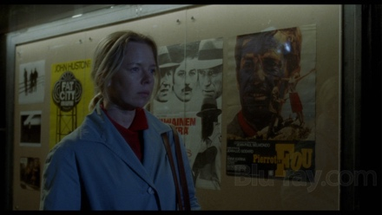 |  | seconds

Part Three: Editing, Music, and Rhythm

250 words on the editing of the sequence with music and sound design to tell the story.

